Household Water-Usage & Billing Monitor

1b) If-Else Condition:

Write a Java program to calculate the water bill based on water consumption. Read the water consumption in litres.

If consumption is 500 litres or less, the bill is Rs.100.

If consumption is more than 500 litres, the bill is Rs.200.

Use an if-else statement and display the water bill.

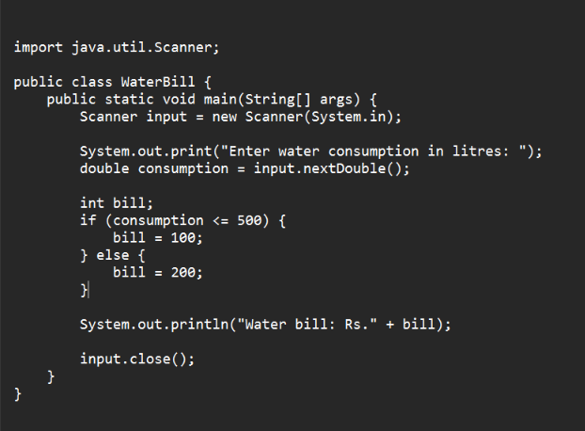
OUTPUT :

